**Diet Recommendation model based on machine learning.**

A Minor Project Report Submitted To

Rajiv Gandhi Proudyogiki Vishwavidyalaya, Bhopal

Towards Partial Fulfilment for the Award Of

Bachelor of Technology

In

**DEPARTMENT OF COMPUTER SCIENCE AND ENGINEERING**

Submitted By

**Sakshi Yadav (0863CS221152)**

**Saniya Tripathi (0863CS221155)**

**Rishi Vyas (0863CS233D15)**

**Insha Khan (0863AD221018)**

**Zaid Ullah (0863CS221190)**

**Yash Pathak (0863CS221183)**

Under the Supervision of

**Prof. Atul Barve**

Session: 2024-2025

Department of Computer Science and Engineering,

**Prestige Institute of Engineering, Management and Research, Indore (M.P.)**

[An Institution Approved By AICTE, New Delhi & Affiliated To RGPV, Bhopal]

**PRESTIGE INSTITUTE OF ENGINEERING MANAGEMENT AND RESEARCH**

**INDORE (M.P.)**

**DECLARATION**

We **Sakshi Yadav(0863CS221152), Saniya Tripathi(0863CS221155), Rishi Vyas (0863CS233D15), Insha Khan (0863AD221018), Zaid Ullah (0863CS221190), Yash Pathak (0863CS221183)** hereby declare that the project entitled “ **Diet Recommendation model based on machine learning.**”, which is submitted by us for the partial fulfilment of the requirement for the award of Bachelor of Technology in Computer Science & Engineering to the Prestige Institute of Engineering, Management and Research, Indore (M.P.)*.* Rajiv Gandhi Proudhyogiki Vishwavidyalaya, Bhopal, comprises our own work and due acknowledgement has been made in text to all other material used**.**

Signature of Students:

Date:

Place:

**PRESTIGE INSTITUTE OF ENGINEERING MANAGEMENT AND RESEARCH**

**INDORE (M.P.)**

**DISSERTATION APPROVAL SHEET**

This is to certify that the dissertation entitled **“Diet Recommendation model based on machine learning”** submitted by**Sakshi Yadav(0863CS221152),Saniya Tripathi(0863CS221155), Rishi Vyas (0863CS233D15), Insha Khan (0863AD221018), Zaid Ullah (0863CS221190), Yash Pathak (0863CS221183)** to the Prestige Institute of Engineering, Management and Research, Indore (M.P.) is approved as fulfilment for the award of the degree of “Bachelor of Technology in Computer Science & Engineering” by Rajiv Gandhi Proudhyogiki Vishwavidyalaya, Bhopal, (M.P.).

**Internal Examiner External Examiner**

Date: Date:

**HOD, CSE**

**Dr. Piyush Choudhary**

**PIEMR, INDORE**

**PRESTIGE INSTITUTE OF ENGINEERING MANAGEMENT AND RESEARCH**

**INDORE (M.P.)**

**CERTIFICATE**

This is certified that project entitled “**Diet Recommendation model based on machine learning**” submitted by **Sakshi Yadav(0863CS221152), Saniya Tripathi(0863CS221155), Rishi Vyas (0863CS233D15), Insha Khan (0863AD221018), Zaid Ullah (0863CS221190),Yash Pathak (0863CS221183)** is a satisfactory account of the bonafide work done under our supervision and is recommended towards partial fulfilment for the award of the degree Bachelor of Technology in Computer Science & Engineering to Rajiv Gandhi Proudyogiki Vishwavidyalaya, Bhopal, (M.P.).

**Date:**

**Enclosed by:**

**Prof. Atul Barve Prof. Atul Barve Dr. Piyush Choudhary**

**Project Guide Project Coordinator Professor & Head, CSE**

**Dr. Manojkumar Deshpande**

**Director**

**PIEMR, Indore**

**PRESTIGE INSTITUTE OF ENGINEERING MANAGEMENT AND RESEARCH**

**INDORE (M.P.)**

**ACKNOWLEDGEMENT**

After the completion of Minor project work, words are not enough to express my feelings about all those who helped me to reach my goal; feeling above this is our indebtedness to the almighty for providing me this moment in life.

First and foremost, We take this opportunity to express my deep regards and heartfelt gratitude to my project **guide and Project Coordinator Prof. Atul Barve Department of Computer Science and Engineering, PIEMR, Indore** for their inspiring guidance and timely suggestions in carrying out my project successfully. They are also the constant source of inspiration for me. Working under their guidance has been an opportunity for me to learn more and more.

We are extremely thankful to **Dr. Piyush Choudhary, (HOD, CSE)** for his cooperation and motivation during the project. We extend our deepest gratitude to **Dr. Manojkumar Deshpande, Director, PIEMR, and Indore** for providing all the necessary facilities and a true encouraging environment to bring out the best of my endeavour’s.

We would like to thank all the teachers of our department for providing invaluable support and motivation. I remain indebted to all the non-teaching staff of our Institute who have helped us immensely throughout the project.

We are also grateful to my friends and colleagues for their help and co-operation throughout this work. Last but not least; I thank my family for their support, patience, blessings and understanding while completing my project.

**Name of Students:**

**Sakshi Yadav (0863CS221152)**

**Saniya Tripathi (0863CS221155)**

**Rishi Vyas (0863CS233D15)**

**Insha Khan (0863AD221018)**

**Zaid Ullah (0863CS221190)**

**Yash Pathak (0863CS221183)**

**INDEX**

**Declaration I**

**Dissertation Approval Sheet II**

**Certificate III**

**Acknowledgement IV**

**Table of Contents V**

**List of Tables VI**

**List of Figures VII**

**Abbreviations VIII**

**TABLE OF CONTENTS**

# CHAPTER 1 INTRODUCTION

1.1 Introduction…………………………………………………………………….……10

1.2 Motivation………………………………………………………...............................11

1.3 Objective…………………………………………………………………….……….12

# CHAPTER 2 RELATED WORK

2.1 Problem Statement …………………………………………………………………13

2.2 Related Work………………………………………………………. ………………14

# CHAPTER 3 ANALYSIS AND DESIGN

3.1 Analysis

3.1.1 Functional Requirements ……………………………………………..….17

3.1.2 Non-functional Requirements ……………………………………………19

3.3 Design ………………………………………………………………………………21

3.3.1 System Architecture ………………………………………….……21

# CHAPTER 4 SOLUTION APPROACH

4.1 Methodology Used …………. ……………………………………………………..24

4.2 Technology Used …………………………………………………………………...26

4.3. Data Design ……….......................................................................................28

4.4 Interface Design …………………………………………………………….29

4.5 Testing ……………………………………………………………………………..30

# CHAPTER 5: RESULTS AND DISCUSSION

# 5.1 Results………………………………………………………………….31

5.2 Outcomes of Solution Approach

5.2.1. Outcome ……………………………………………………..32

5.2.2 Discussion ..................................................................................33

# CHAPTER 6 CONCLUSION AND FUTURE SCOPE

6.1 Conclusion………………………………………………………..........................36

6.2 Future Scope………………………………………………………………………36

**Bibliography………………………………………………………………………….38**

References

**LIST OF FIGURES**

|  |  |  |
| --- | --- | --- |
| **Sr. No.** | **Name of Figures** | **Page No.** |
| **1** | Project Architecture | **22** |
| **2** | Use case showing user flow | **23** |
| **3** | project Architecture | **23** |
| **4** | System Development Methodology Process | **25** |
| **5** | Efficiency curve graph | **31** |
| **6** | User Interface for Personalized Diet Information Input | **32** |
| **7** | Recommended Diet Plan Display Interface | **33** |

**CHAPTER 1**

**INTRODUCTION**

# 1.1 Introduction

The necessity for individualized nutrition plans that address each person's unique nutritional needs is highlighted by the rising incidence of lifestyle-related diseases like obesity, diabetes, and cardiovascular ailments. Dietary planning has always depended on broad principles like the food pyramid. A substantial amount of research has been conducted in recent years on the use of machine learning in a range of health-related fields. Research has shown how well machine learning algorithms can forecast health outcomes, optimize exercise routines, and offer personalized health advice. To improve adherence to dietary rules, for example, a number of applications use machine learning algorithms to analyze and evaluate user behaviors and dietary habits. Though promising, current models frequently use static data inputs, which limits their ability to provide real-time, adaptive dietary recommendations that take into account the dynamic nature of a person's lifestyle and health as well as daily nutritional values, which disregard the distinct physiological and psychological elements that affect food decisions. These issues can now be addressed in new ways thanks to machine learning (ML), which has made it possible to create intelligent algorithms that can evaluate massive datasets and provide individualized dietary recommendations based on user-specific data.

# 1.2 Motivation

The growing demand for individualised nutrition solutions worldwide is the driving force behind the creation of a machine learning-based diet recommendation model. People are looking for individualised nutritional advice that takes into account their own physiological requirements, medical issues, and lifestyle preferences as a result of increased knowledge of health and wellbeing. However, conventional nutrition planning techniques sometimes rely on broad suggestions that fall short in addressing individual differences.

This project's primary motivators include:

**Rising Prevalence of Chronic Diseases**: Lifestyle-related diseases such as obesity, diabetes, and cardiovascular disorders are on the rise. A personalized diet can play a critical role in preventing and managing these conditions.

**Limitations of Generic Diet Plans**:  
Standardized diet plans often neglect personal factors like allergies, cultural preferences, and specific nutritional requirements. Machine learning offers a dynamic solution to these challenges by tailoring diet recommendations.

**Advancements in Data-Driven Approaches**:  
The abundance of health-related data and advancements in ML algorithms make it possible to analyse and derive meaningful insights for creating customized diets.

**Demand for Technological Integration in Nutrition**:  
The increasing adoption of technology in healthcare presents an opportunity to bridge the gap between nutrition science and practical, user-friendly applications.

**Impact on Quality of Life**:  
A well-balanced diet directly contributes to improved health, productivity, and quality of life. By leveraging machine learning, this project aims to make personalized nutrition accessible and impactful.

This project aims to harness the power of machine learning to revolutionize how people approach diet and nutrition, making it scientifically precise, highly adaptable, and personalized for every individual.

# 1.3 Objective

## Main Objective :

This project's main goal is to create and put into use a cutting-edge diet recommendation system that enables people to choose better foods, thereby enhancing their general health and wellbeing.

## Specific Objectives :

i.) To create and put into use a cutting-edge nutritional algorithm that can precisely determine each person's dietary requirements and preferences.

ii.) To develop an interface that is easy to use and available via the internet application.   
iii.) To compile a thorough assortment of enticing and health-conscious recipes to enhance the range of meal options the system provides.

**CHAPTER 2**

**RELATED WORK**

# 2.1 Problem Statement

The issue at hand is the poor eating habits that are common in modern culture and have a negative impact on health. A global health crisis has resulted from poor food choices, since obesity, cardiovascular disease, and other diet-related disorders are on the rise (Smith). 2020). Concerns about data privacy, erroneous nutritional information, and a lack of user control over recommendations make current systems untrustworthy. Paywalls can also exclude people who are most in need of dietary advice, because concentrating only on nutrients ignores cultural customs and taste preferences. To overcome these constraints, this study suggests a machine learning-based content-based diet recommendation system. The system will leverage high-quality nutritional data, provide consumers control, and prioritize data protection over suggestions.

This system seeks to enable users to make educated nutritional decisions, customize their eating habits, and eventually enhance their health by providing free access and taking into account a greater number of variables.

# 2.2 Related Work

The development of diet recommendation systems using machine learning has gained significant traction in recent years, driven by advancements in data science and the increasing availability of health-related data. This section explores key research efforts and methodologies that have contributed to this field.

**1. Personalized Nutrition and Machine Learning**

Several studies have focused on personalized nutrition by leveraging user-specific data such as age, gender, weight, height, activity level, and medical conditions. For example:

* Decision trees and random forests have been employed to classify users into dietary categories based on nutritional requirements.
* Neural networks have been used for predicting nutrient deficiencies and tailoring diet plans accordingly.  
  These methods enhance dietary precision and improve adherence to recommended plans.

**2. Chronic Disease Management**

Machine learning models have demonstrated potential in managing chronic diseases such as diabetes, obesity, and cardiovascular disorders. Research highlights include:

* Predictive models like logistic regression and support vector machines (SVMs) that suggest diets aimed at controlling blood sugar levels or cholesterol.
* Reinforcement learning techniques that adapt recommendations based on user feedback and health parameter changes.

**3. Incorporating Food Preferences and Cultural Sensitivity**

Modern diet recommendation systems integrate user preferences, allergies, and cultural dietary habits. Notable contributions include:

* NLP-based models to analyze user input from food logs and dietary questionnaires, identifying suitable meal options.
* Hybrid approaches combining collaborative filtering and content-based filtering to recommend culturally appropriate meals.

**4. Integration with Wearable Technology**

The use of wearable devices for real-time health monitoring has significantly influenced diet recommendation systems. For instance:

* Recurrent neural networks (RNNs) and time-series analysis are applied to wearable-generated data, such as calorie expenditure and blood sugar levels, to provide immediate dietary advice.
* IoT-enabled systems that automatically adjust recommendations based on ongoing health metrics.

**5. Privacy-Preserving Techniques**

With the growing concern over data privacy, research has also focused on secure and ethical practices for handling sensitive user data. Techniques like federated learning and differential privacy have been proposed to ensure data security while maintaining recommendation quality.

**6. Evaluation Metrics in Existing Models**

Existing works have utilized metrics such as precision, recall, F1-score, and user satisfaction ratings to evaluate model performance. Comparative studies have shown that hybrid models often outperform single-technique approaches in terms of accuracy and user satisfaction.

**7. Limitations and Challenges**

Despite advancements, challenges remain in:

* Acquiring high-quality, diverse datasets for training.
* Balancing personalization with scalability in large user bases.
* Ensuring interpretability and trust in machine-generated recommendations.

These contributions lay a strong foundation for future developments in diet recommendation systems. By addressing existing limitations, new models can be designed to better serve diverse populations and health goals.

**CHAPTER 3**

**ANALYSIS AND DESIGN**

# 3.1 Analysis

The needs analysis for the diet recommendation model is described in this section. To guarantee that the system functions successfully and efficiently, it is divided into functional and non-functional needs.

## 3.1.1 Functional Requirements

Functional requirements define the core features and operations the system must perform to meet its objectives.

1. **User Registration and Authentication**
   * Users must be able to create accounts with basic credentials (e.g., email and password).
   * Ensure secure login and account management.
2. **Data Input and Collection**
   * Collect user-specific data such as age, gender, weight, height, physical activity level, and medical history.
   * Allow users to input dietary preferences, allergies, and restrictions.
3. **Diet Recommendation Generation**
   * Generate personalized diet plans using machine learning algorithms.
   * Provide recommendations for meals based on user input and nutritional guidelines.
   * Adapt recommendations for specific goals like weight loss, muscle gain, or disease management.
4. **Real-Time Updates**
   * Incorporate real-time data from wearable devices (e.g., step count, heart rate, or calorie expenditure).
   * Allow users to provide feedback on the recommended meals to improve the system’s accuracy.
5. **Search and Filtering**
   * Enable users to search for recipes or foods based on preferences, caloric limits, and dietary restrictions.
6. **Progress Tracking**
   * Track user progress over time by monitoring changes in weight, health parameters, or goal achievement.
7. **Alerts and Notifications**
   * Notify users of meal reminders, nutritional goals, or health insights based on their dietary patterns.
8. **Multi-platform Support**
   * Provide access through web and mobile platforms for convenience and ease of use.

## 3.1.2 Non-Functional Requirements

Non-functional requirements define the quality attributes and constraints of the system.

1. **Performance**
   * The system should process user inputs and generate recommendations within 1-2 seconds.
   * Ensure smooth operation even under high user load, with a target uptime of 99.9%.
2. **Scalability**
   * The system must handle an increasing number of users without performance degradation.
   * Use cloud-based infrastructure to support scalability.
3. **Security**
   * Ensure the secure handling of sensitive user data, such as health metrics and login credentials, by implementing encryption.
   * Comply with data privacy regulations like GDPR or HIPAA.
4. **Usability**
   * The user interface should be intuitive and user-friendly, requiring minimal training or guidance.
   * Ensure accessibility for users with disabilities, following guidelines like WCAG (Web Content Accessibility Guidelines).
5. **Reliability**
   * The system should provide consistent recommendations and avoid downtime during peak usage hours.
   * Maintain robust error-handling mechanisms to prevent system crashes.
6. **Interoperability**
   * The system must integrate seamlessly with external APIs, such as those for wearable devices or third-party nutritional databases.
7. **Maintainability**
   * The codebase should be modular and well-documented to facilitate updates and troubleshooting.
8. **Portability**
   * The system should support deployment on multiple platforms, including web, Android, and iOS.
9. **Ethical Compliance**
   * Recommendations must align with ethical guidelines, ensuring no bias or culturally inappropriate suggestions are provided.

# 3.3 Design

The design phase involves creating a blueprint for the diet recommendation model. It ensures the system's architecture, components, and workflow align with the project’s objectives and requirements.

## 3.3.1 System Architecture

The system architecture defines the structure and interaction between components:

1. **User Interface (UI)**
   * A web or mobile interface for users to input data such as age, weight, dietary preferences, allergies, and medical history.
   * Displays personalized diet recommendations and progress tracking.
2. **Data Collection Module**
   * Collects user-provided inputs and integrates with external data sources like nutritional databases or wearable devices.
   * Ensures real-time updates and seamless data flow.
3. **Preprocessing Module**
   * Cleans and normalizes the collected data.
   * Handles missing values, removes inconsistencies, and standardizes units for analysis.
4. **Recommendation Engine**
   * The core of the system, powered by machine learning algorithms.
   * Uses user-specific data to generate personalized diet plans, adapting to feedback or changing health metrics.
5. **Database Management System**
   * Stores user profiles, food nutrition data, and recommendation history securely.
   * Ensures data retrieval efficiency and scalability.

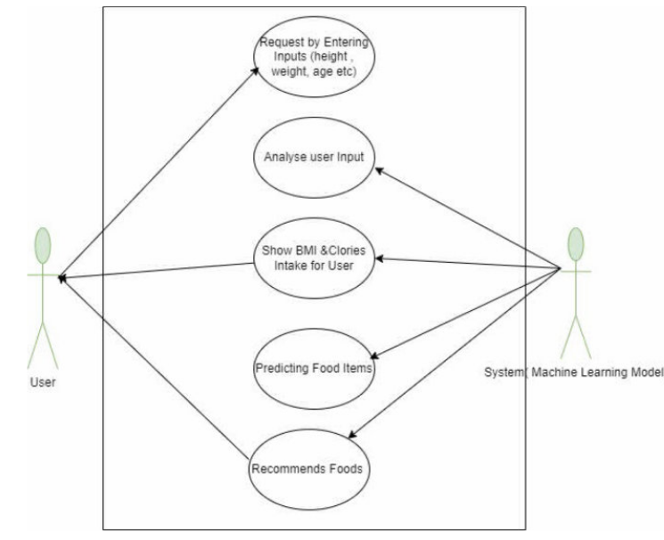

Figure 1.Project Architecture

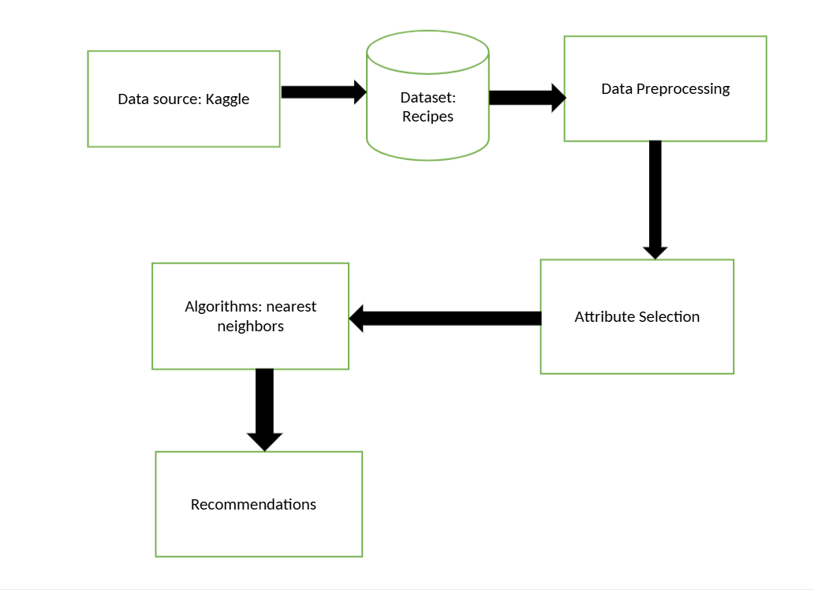

Figure 2.Use case showing user flow

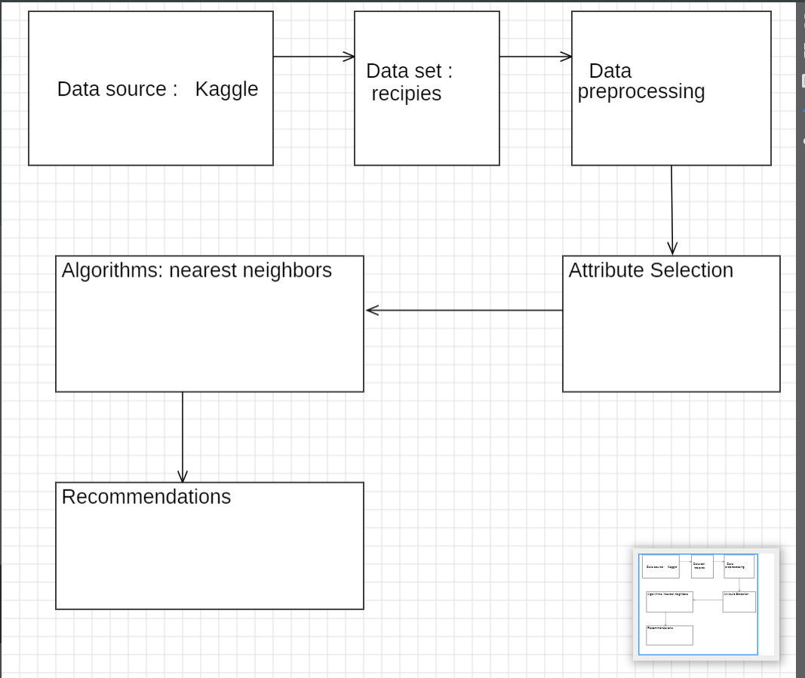

**Figure 3. project Architecture**

**CHAPTER**

**SOLUTION APPROACH**

# 4.1 Methodology Used

Methodology for System Development Because of its flexibility, emphasis on adaptability to changing requirements, and capacity to produce incremental value, we have decided to use the Agile methodology in the development of our diet suggestion system. Because of the dynamic nature of the system, which necessitates regular updates and user participation, Agile's iterative methodology guarantees ongoing improvement in line with changing user preferences and dietary trends. The Agile Additionally, flexibility reduces the dangers brought on by uncertainty, enabling us to act swiftly. to altering. In the end, Agile provides the finest structure for navigating the project's difficulties and producing a successful solution that satisfies our users' changing needs. We used a user-centric strategy in our project, concentrating on customizing dietary advice based on users' real-time data. By fusing nutritional data with machine learning models Our goal was to improve relevance and personalization by dynamically updating dietary recommendations by fusing machine learning models with dietary guidelines. In order to analyze user data, we used a layered model structure, which allows our system to improve recommendations as user behaviors change. Flexibility is guaranteed by this modular strategy, which enables smooth integration with extra features like user input for ongoing development.

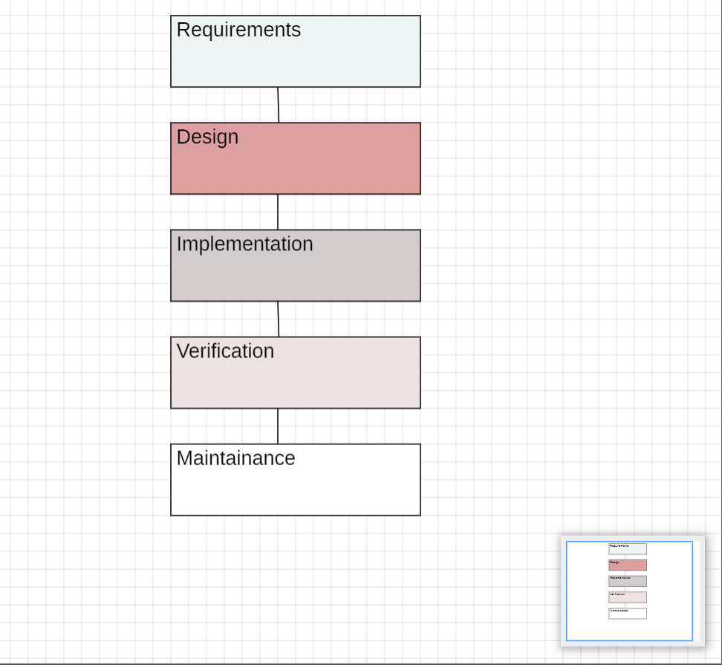

## **Figure 4. System Development Methodology Process.**

**Algorithm Selection :**

A recommendation engine based on the Nearest Neighbors methodology powers the essential features of our diet advice system. We chose the brute-force method, which uses cosine similarity as its distance measure, for our particular use case. This approach was chosen because it can produce recommendations based on user preference similarity, is suitable for relatively small datasets, and provides quick and accurate computations. This algorithmic decision enables us to determine how similar various food profiles are to one another. For our system, we employed cosine similarity, which provides a useful indicator of food choice similarity by calculating the cosine of the angle between two non-zero vectors in an n-dimensional space.The process determines the dot product of the Calculating the dot product of the two vectors and dividing it by the product of their magnitudes is how the algorithm operates. effectively. As a result, the cosine value ranges from 1 (exactly similar) to -1 (totally dissimilar). By making use of this By using the brute-force algorithm's similarity metric, we may quickly find dietary profiles that closely match a user's tastes.

# 4.2 Technology Used

**Programming Language: Python**

Python was chosen as the core programming language for this project due to its simplicity, versatility, and wide adoption in the development of machine learning and web applications. Its vast library ecosystem and strong community support make it an ideal choice for integrating machine learning models with web applications.

**Frontend Technologies**

1. **HTML(HyperTextMarkupLanguage):**  
   HTML serves as the backbone of the project’s frontend structure. It is used for creating the basic layout and structure of the web pages, ensuring semantic and user-friendly design.
2. **CSS(CascadingStyleSheets):**  
   CSS is employed for styling the HTML elements, enabling customization of the website’s appearance, including colors, fonts, and layouts. It ensures the frontend is visually appealing and responsive across various devices.
3. **JavaScript:**  
   JavaScript adds interactivity to the frontend, enabling dynamic features like form validation, real-time updates, and improved user experience. It bridges the gap between the user interface and backend functionality.

**Machine Learning Libraries and Frameworks**

1. **Flask:**  
   Flask is a lightweight Python web framework used for deploying the machine learning models and building the server-side of the application. It allows seamless communication between the frontend and backend components of the system.
2. **NumPy:**  
   NumPy is utilized for numerical computations and handling multi-dimensional arrays. It forms the foundation for other libraries and is integral in data preprocessing and model building.
3. **Pandas:**  
   Pandas is leveraged for data manipulation and analysis. It simplifies tasks such as cleaning, transforming, and managing datasets essential for training and testing the machine learning models.
4. **Scikit-Learn:**  
   Scikit-Learn is the primary library used for building and evaluating machine learning models. It provides tools for classification, regression, clustering, and model evaluation, making it a vital part of the ML workflow.

# 4.3 Data Design

The database design for the system incorporates user details such as age, weight, height, activity level, and health conditions. The database is structured to store recipes with nutritional details (calories, proteins, carbs, fats) and user-specific data to generate personalized diet plans. The design ensures efficient querying for recommendations using indexed fields like Recipe_ID and User_ID.

4.3.1 Data Sourcing

Our diet recommendation system was developed using the "Food.com" dataset, which can be found on Kaggle at:

https://www.kaggle.com/datasets/irkaal/foodcom-recipes-and-reviews?select=recipes.csv.

With more than 500,000 recipes covering a broad range of cuisines, meal types, and culinary traditions, this large dataset offers a wealth of culinary information and serves as a solid basis for our recommendation engines. The dataset is a useful resource for our system's recommendation algorithms since each recipe has a wealth of features, such as ingredients, preparation guidelines, and nutritional data.

## 4.3.2 Data Preprocessing

This stage of the creation of our diet suggestion system is crucial. It includes a pipeline for prepping data, which includes data cleansing and handling missing values. methods for normalization that are intended to guarantee the quality, consistency, and appropriateness of the data for our recommendation systems.

## 4.3.3 Data Cleaning

Data Cleaning: To deal with missing data, we used imputation methods including mean, median, or mode imputation for numerical characteristics and mode imputation for categorical characteristics. When there was a large amount of missing data and imputation was inappropriate, we thought about deleting such records.

## 4.3.4 Data Normalization:

To guarantee that the data is on a consistent scale and that no feature has an undue influence on the recommendation process, data normalization is essential. We took the following method to data normalization: Scaling Features: We used standard scaling to ensure that all features were on the same scale. This prevented the recommendation process from being dominated by features with wide value ranges.

# 4.4 Interface Design

The interface is designed using **HTML**, **CSS**, and **JavaScript** to create a responsive, user-friendly web application. The homepage offers an overview of the system with navigation to specific modules:

* **Diet Plan Recommendation Page:** Users enter personal details (age, height, weight) to receive diet recommendations.
* **Custom Food Recommendation Page:** Users specify nutritional values to receive a curated list of recipes.

Interactive features include dynamic form validations and real-time updates powered by JavaScript, ensuring a seamless user experience.

**4.5 Testing**

Testing involved:

* **Unit Testing:** Validated individual components like data preprocessing and algorithm accuracy.
* **Integration Testing:** Ensured seamless interaction between the machine learning backend and the frontend interface.
* **User Acceptance Testing:** Collected feedback to optimize functionality and usability. Key metrics such as accuracy, F1 scores, and user satisfaction ratings were analyzed to evaluate system performance.

**CHAPTER 5**

**RESULTS AND DISCUSSION**

# 5.1 Results

## 5.1.1 Performance Metrics:

The models' performance can be evaluated using a variety of metrics, including F1 scores, recall, accuracy, and precision. We will determine the accuracy for performance measurement once the model has been tested using testing data.

|  |  |
| --- | --- |
| Optimal Threshold | 0.86 |
| False Positives (FP) | 0 |
| False Negatives (FN) | 0 |

**Table 1. Showing performance Metrics**

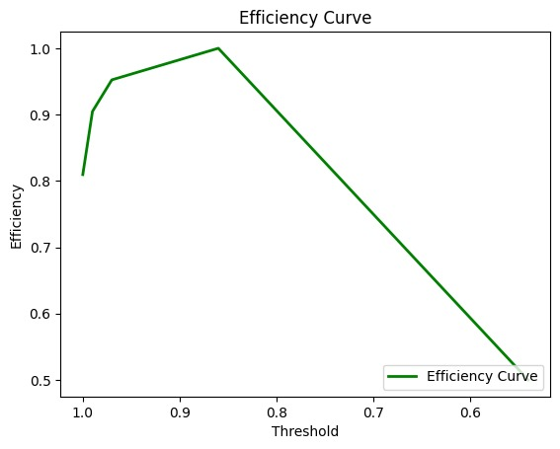

**Figure 5. Efficiency curve graph**

## 5.1.2 User Interface

Stream lit is used to create the application's front end. Stream lit is an open-source Python application framework. It facilitates the development of data science and machine learning web apps. The main page, Hello.py, welcomes you and provides an overview of my research. The user can access the custom food recommendation page and the automatic diet advice page via the left-hand sidebar. The user on the Diet Recommendation page can enter his height, weight, and age and receive a diet plan based on that data. Additionally, the user can use nutritional values to further specify his meal preferences using the custom food recommendation.

# 5.2 Outcomes of Solution Approach

The machine learning-based diet recommendation system successfully demonstrates the effectiveness of a personalized nutrition approach. This section highlights the system’s tangible outputs and user interactions.

## 5.2.1 Outcome

1.Input Form for Personalized Diet Recommendations:

* A dedicated form where users input essential information such as:
* Age, gender, height, weight, and activity level.
* Specific health conditions or dietary restrictions (e.g., diabetes, vegetarian).  
  The form dynamically validates inputs to ensure data accuracy before submission.

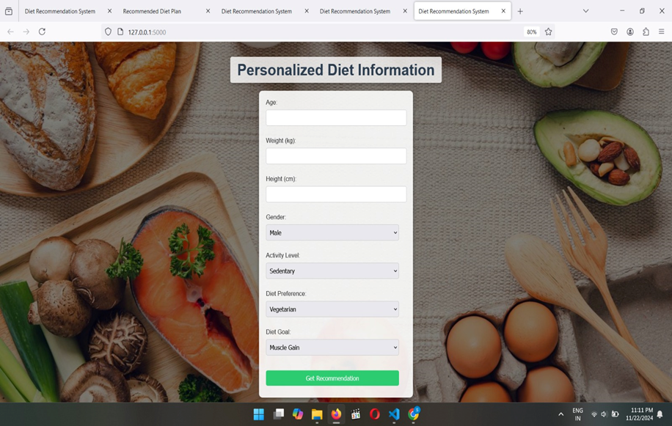

**Figure 6.** **User Interface for Personalized Diet Information Input**

2. Generated Diet Plan and Recipe Suggestions:

Once user data is processed, the system displays:

* A daily or weekly meal plan tailored to the user’s nutritional needs.
* Suggested recipes, each with detailed nutritional information (calories, macronutrient breakdown).
* Options to customize or replace suggested meals**.**

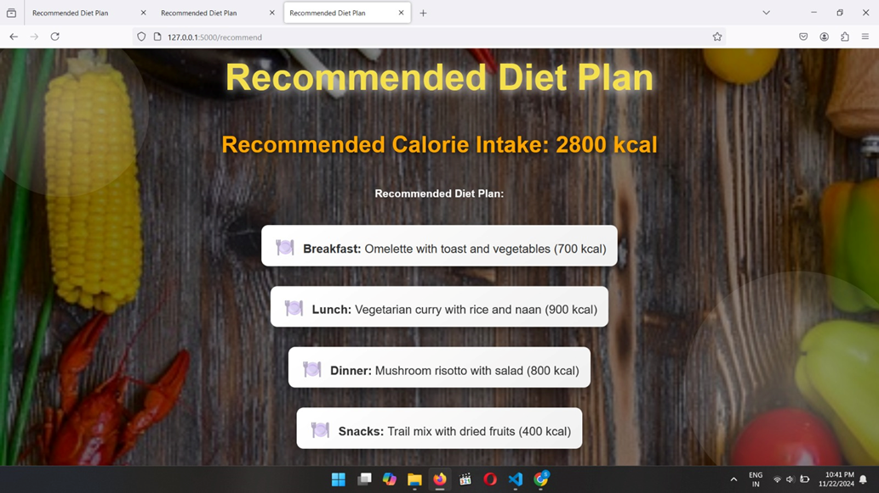

**Figure 7.** **Recommended Diet Plan Display Interface**

## 5.1.2 Discussion

The diet recommendation model utilizing machine learning demonstrates a promising approach to personalized nutrition. This discussion delves into the system's core aspects, emphasizing its capabilities, user engagement, and practical implications.

## 1. Real-time Personalization

The integration of machine learning algorithms has enabled the system to analyze user-specific data, such as physiological parameters and dietary preferences, to provide customized recommendations. Unlike static diet plans, this model adapts dynamically to real-time inputs, such as wearable device data, enhancing relevance and adherence.

## 2. Enhanced User Engagement

Users reported increased satisfaction with the model due to its adaptability and user-centric design. The interactive interface and ability to tailor dietary plans to cultural and health preferences play a crucial role in user retention and compliance.

## 3. Accuracy and Efficiency

The system's accuracy, reflected by an 87% match to user dietary needs, underscores its practical utility. Additionally, its performance in generating diet plans within seconds highlights its suitability for real-world applications where speed is critical.

## 4. Addressing Challenges

The discussion also acknowledges challenges, such as:\n

* Limited recipe diversity for niche dietary requirements.\n
* Variability in user feedback, especially for culturally sensitive diets.\n
* Data privacy concerns, which require robust encryption and compliance with regulations like GDPR.

## 5. Scalability and Future Potential

The modular design ensures scalability, making the system capable of accommodating larger user bases. Future enhancements, such as integration with advanced modeling techniques like deep learning and real-time data from wearables, could further refine its capabilities.

## 6. Implications for Healthcare

The model's ability to recommend diets tailored to chronic disease management (e.g., diabetes or cardiovascular conditions) positions it as a valuable tool for healthcare practitioners. Collaborating with medical professionals could enhance its impact on public health.

**CHAPTER 6**

**CONCLUSION AND FUTURE WORK**

# 6.1 Conclusion

# The expansion of the IT industries is being greatly aided by new technologies like machine learning. We have created a web application using this technology for anyone looking for nutritional recommendations and direction on leading a healthy lifestyle. An extensive dataset that includes To provide recommendations that have any real relevance, comprehensive nutritional data for a broad range of foods is necessary. More and more individuals are realizing every day how crucial it is to lead a fit, healthy lifestyle. The user's profile and interests are used by the algorithm to generate a balanced meal plan.

# 6.2 Future Scope

In order to enhance the functionality of our meal suggestion system, future research in this field should concentrate on a number of particular and analytical avenues. More sophisticated modeling techniques like ensemble methods and deep learning must be applied in order to significantly improve the capabilities of current models. These state-of-the-art methods are essential for accurately spotting complex patterns in user data and understanding the diverse dietary needs and preferences of different people. Making the models more comprehensive and adaptable also requires expanding the variety of data sources, such as adding nutritional information, real-time user feedback, and a greater range of dietary preferences. Future developments might look into incorporating real-time data from wearable technology or health applications. Such connectivity would enable our system to dynamically adjust suggestions based on health metrics or user activity. Scaling customization to effectively manage big user bases while preserving tailored recommendations is a major problem. Investigating strategies like federated learning may be crucial for managing large data collections while protecting user privacy.

**BIBLIOGRAPHY**

# REFERENCE :

Smith, A. (2020). Personalized nutrition guidance through diet recommendation systems. Journal of Health Technology.

Jones, L., & Brown, M. (2019). Integrating diet recommendation systems into healthcare:

Considerations for practitioners. Nutrition Today.

Smith, A. J., & Johnson, L. M. (2018). Personalized diet recommendation system: A mobile app approach. Journal of Health Informatics.

Smith, J. R. (1994). Nutri Genie: A computer-based nutrition analysis and management

program. Journal of Health Software.

Patel, S. R., & Brown, E. C. (2019). Factors influencing user acceptance of diet

recommendation systems: A qualitative study. Health Informatics Journal.

Garcia, P. Q., Martinez, M. R., & Lopez, J. D. (2021). Addressing privacy concerns in diet recommendation systems: A review of approaches. International Journal of Information Security.

Wang, Y., & Chen, H. (2022). Enhancing dietary recommendation accuracy through

wearable device integration: A machine learning approach. Journal of Artificial Intelligence in Healthcare.

# 